Project Proposal (Android Application)

My Movie Database

My project is aimed at letting a user create and handle a database of his/her favourite movies. It allows user to maintain a list of their favourite movie titles. And information for each movie title stored can be fetched via third party APIs. The user interactions can be explained as follows:

1. Home Screen:
   1. Users will be able to search for a movie using a search bar providing the movie titles
   2. Users can see their favourite movie list
   3. Users can delete movies from their favourite movie list.
2. Search Result Screen:
   1. All matching movies titles will be shown here as per the search term entered by user
   2. User can click on a result to see detailed info
3. Movie Detail Screen:
   1. User will be able to see all the movie information collected via third party API
   2. User will be able to add the movie in their favourite movie list.

Wireframes:

When user searches for a movie on homescreen:

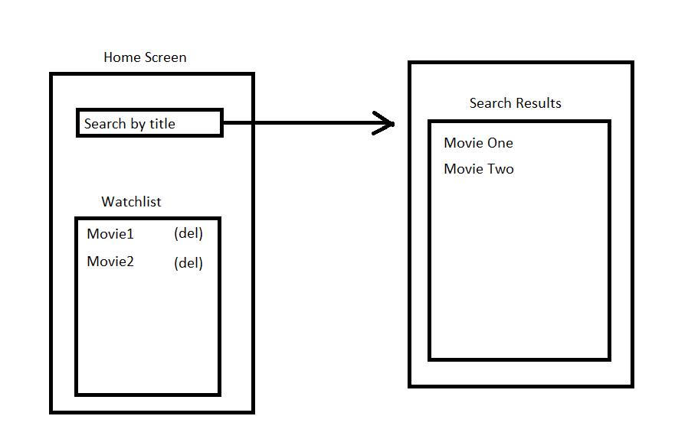

When user clicks on movie title to see details:

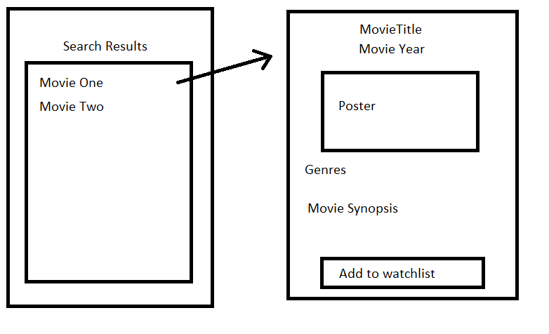

When user clicks on movie from his watchlist:

